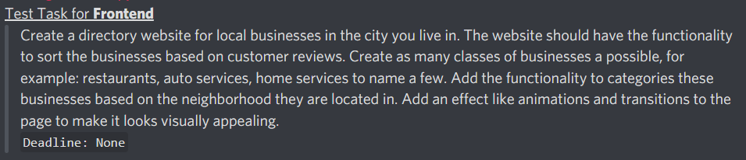

Create a directory website for local businesses in the city you live in. The website should have the functionality to sort the businesses based on customer reviews. Create as many classes of businesses a possible, for example: restaurants, auto services, home services to name a few. Add the functionality to categories these businesses based on the neighbourhood they are located in. Add an effect like animations and transitions to the page to make it looks visually appealing.

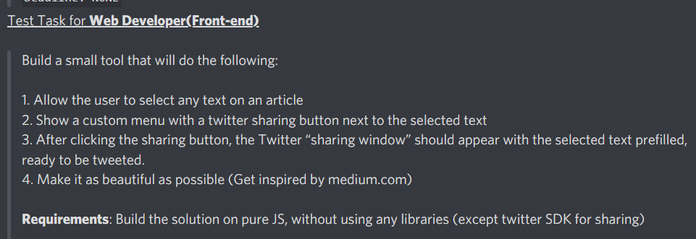

Templates:

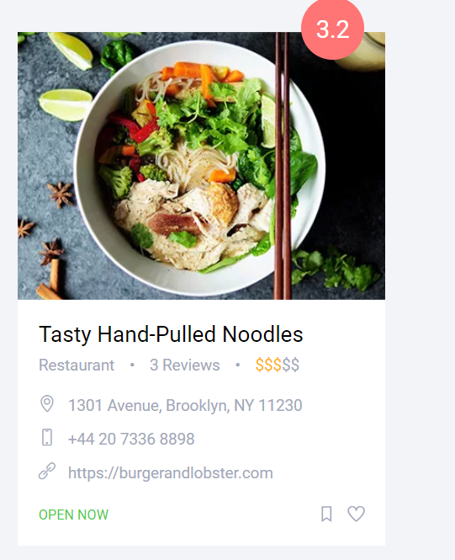 Bakery

Doctors

